**Assignment Information and Goal**  
In this class assignment you will demonstrate a detailed knowledge of Drupal 8 CMS site development skills by creating a Drupal 8 site and extending it with menus, images, themes, plugins, pages and posts.   
The goal of this assignment is to demonstrate that you have learned how to extend Drupal with Taxonomy-Vocabularies-Terms, custom content types, and fields.  
  
**Assignment questions are not as detailed as activity questions. The assignment is where you demonstrate understanding of the material.  
  
Read All Project Documents before Starting the Work**Please read this document completely before starting the project work.   
Please also read the template so that you understand what information, content, and screens you are required to capture and insert into the template file.

**Documents for This Assignment:**   
This is the assignment instructions document.   
It contains the information on the necessary tasks to be completed for the assignment.  
The other documents associated with this assignment are the assignment template, the website content, and the rubric.   
  
**Website Content document:**   
The Website Content document contains business information and all the necessary CMS web page content required to create the Drupal site.   
  
**Template File:**   
Please download, rename, complete and then submit the assignment template document to receive a grade for this assignment. Please provide partial screen captures where requested.  
The rubric provides detailed information on how the assignment is graded.  
**PLEASE DO NOT DELETE PARTS OR ALTER SECTION FORMATTING OF THIS TEMPLATE**

**Assignment Asset Folders and Website Content**   
There are asset folders that contain images and website page and post content.  
The asset folders contain images and content to use on the CMS website.   
Please use the content and image assets provided on the D2L CMS to complete the assignment.

**Creating the Drupal 8 Website:**Create the Drupal 8 CMS website.  
Create the Drupal 8 site on your web host.  
Create the Drupal 8 site as an “In Directory” website on a shared web host or Pantheon.  
Please use all lower case in directory name when creating the website.   
Drupal can create case sensitive website URLs so please adhere to the instructions for site name.

Please contact the instructors if you have questions about the assignment, content layout, or formatting.

**Part A - Student Information**

1. Download and save a copy of the Assignment 09 Template document
2. Rename the template document **[Your-Initials]-**Assignment09.docx
3. Go to the template and enter part A student information.

**Part B - Create Drupal 8 CMS Website - Shared web Host or Pantheon**

1. If you are using a shared web host create an “In Directory” Drupal 8 CMS website with the following attributes  
    **For Shared Web Host:**

**Protocol:** http:// **Domain:** Select your default domain **In Directory:** “assignment09”

**Site Name:** “Assignment 09 Drupal 8 Site”

**Site Description:** “IT320 Assignment 09”

-OR-  
**For Pantheon:**

If you are creating a Pantheon Drupal 8 site, create a site with the following attributes:  
**Site Name:** “Assignment 09 - PA”

1. Go to the template and record website creation settings in part B.

**Part C - Review the Assets Photograph Record Content text File**

The following is a screen capture of the first 27 lines of the Assets file   
“Photograph Record Content.txt “   
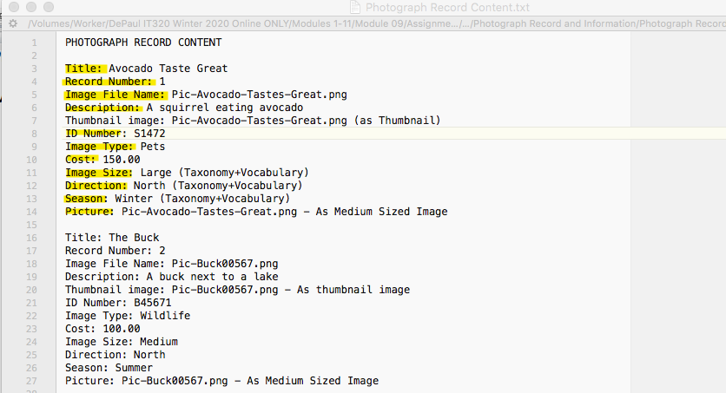

The “Photograph Record Content.txt” file contains the record structure, field names and values for 6 (six) Photographic records.

Each Photographic record contains (twelve) fields used to create a new custom Content Type named “Photograph”.

Please review the table below and analyze the table information to identify the Taxonomy-Vocabularies. They should be easily identifiable – with terms like “**One of these values**” in the Field Type column.

Use the table below and the “Photograph Record Content.txt” file to create new Taxonomy-Vocabularies and add the terms to each vocabulary.

After adding the terms to the vocabularies, create a new custom content type named “Photograph record”. Maintain the table field order and add taxonomy-vocabulary references to the content type record. Use radio buttons for all vocabularies on the content type.

|  |  |  |  |  |
| --- | --- | --- | --- | --- |
| Field # | Field Name | Description | Field Type/Info | Required (Y/N) |
| 1 | Title | The title of the Photograph | Use the Content type Title | (N/A) |
| 2 | Record Number | The record number 1-6 | Number (integer) | Y |
| 3 | Image File Name | Name of the photograph file . To be used for thumbnail and Picture | Text (plain) | Y |
| 4 | Description | The description text (content) of the photograph | Text (plain long) | Y |
| 5 | Thumbnail Image | A thumbnail image goes at this point in the record layout | Image – Formatted as Thumbnail | Y |
| 6 | ID Number | An alpha numeric and unique number that is the image catalog ID. | Text (plain) | Y |
| 7 | Image Type | The type of image. | One of these values: Wildlife, Commercial, or Pet | Y |
| 8 | Cost | The Picture cost. | Number (float)  with $ Prefix | Y |
| 9 | Image Size | The generic size of the image – used for selecting frame size | One of these values: Medium, Large, or X-Large | Y |
| 10 | Direction | The direction the photographer faced when taking the image. Used for marketing. | One of these values: North, South,  East, or West | Y |
| 11 | Season | The season of the year when the photograph was taken. Used for marketing. | One of these values: Winter, Spring, Summer, or Fall | Y |
| 12 | Picture | The medium sized Picture goes at the end of the structure | Image – formatted as Medium size | Y |

Go to the template, answer the questions for **Part C**, and in the template.

**Part D - Create Custom Content Type named “Photograph record”**

1. Create a new custom content type named “Photograph record”
2. Please add help text for all fields
3. Set Publishing options to “Published” only – do not promote to the front page
4. Menu settings – Uncheck all menu settings.
5. Add all fields and vocabulary references to the template structure
6. Configure all vocabulary reference to use a radio button widget
7. Hide image labels

Go to the template, answer the questions for **Part D**, and in the template.

**Part E – Add “Photograph record” nodes to the system**

1. Add all six data records (nodes) to the system adding all field items to each record.

Go to the template, answer the questions for **Part E**, and in the template.

**Part F – Configure view and Create a “Photograph record” View**  
Navigate to the View settings page and   
(1) Enable the “always show Advanced display settings” option  
(2) In the LIVE PREVIEW SETTINGS section, enable the “Show SQL query” option   
(3) Press the “Save configuration” button

View is created with the following attributes:

1. View name “My photograph view 1”
2. Description: “A teaser view of type Photograph record.”
3. View settings:
   1. Show: Content
   2. Of type: photograph RECORD
   3. sorted by: Title
4. Select (check) Create a page
5. Page title and path: default values
6. PAGE DISPLAY SETTINGS
   1. Display format: Unformatted list
   2. Of: teasers
7. Items to display: 3
   1. Use a pager: checked
   2. Create a menu link: checked
      1. Menu: main navigation
      2. Link text: keep default value

Go to the template, take screen captures for **Part F**, and in the template.

**Part G – Drupal 8 Hook API:**

Go to the template, and answer the questions about Drupal 8 API Hooks for **Part G**, and in the template.

**Part H – Java Script Libraries:**

Install a libraries folder for this Drupal 8 site.   
Get the WooCommerce FlexSlider JavaScript library GitHub at:  
<https://github.com/woocommerce/FlexSlider>

After downloading the zip file, add the FlexSlider JavaScript library to your site’s libraries folder and extract it in place.   
**Pantheon users:** Please extract the zip file locally and upload the extracted files to your Pantheon  
Drupal 8 file system libraries folder.  
  
Go to the template, and answer the questions and take screen captures for **Part H**, and in the template.

**Part I – Assignment Wrap up:**

1. Go to the template and answer the questions in Part I, the assignment wrap up.
2. After that submit your renamed template to D2L.